

Mrs. Mithila Pradeep Joshi ( M.Sc. B. Ed.)
Dr. Kalmadi Shamarao High School, Ganeshnagar.
Total work experience- 24 years.

She has been working as a Mathematics teacher in Dr.Kalmadi Shamarao High School, Ganeshnagar, since 15 years. She got an opportunity to head the Department of Mathematics in 2010 and she continues to do that till date. She is also in charge of the Math Laboratory too.
She has received Gloria de Souza Excellence award in 2017 instituted by Parisar Asha, Centre for Educational Research and Training for the work done in the field of Education. She has also been awarded two times as best teacher in school.
She has worked as a co-author in publishing the books of paper sets of std X students.
_____________________________________________________________

5 E LESSON PLAN

( A) General Information :

1. Name of the school : Dr Kakmadi Shamarao high School.

2. Name of the teacher : Mrs. Mithila Pradeep Joshi

3. Date: 14 January 2019

4. Subject : Mathematics

5.Grade : Std 8

6. Topic : Data Handling

7. Unit : Statistics

8.Curriculum Standards : CBSE

(B) Lesson / Unit Planning :

1.Short description of the concept : Organization of the given data in grouped frequency distribution table & representation of data in Histogram.

2. Statement of learning objective: After the lesson students of std 8 will be able to organize the data and prepare / draw Histogram.

3. Differentiation Strategies to meet diverse learner needs: to compare the bar graph and histogram.

4. Common Learners Misconception: Selecting the type of graph.
(bar graph or Histogram ) Selecting the scale. Confusion in 'X' axis & Y axis.

5. Adaptation / Accommodation for Exceptional Students : (1)To collect the data from NET from 2010 to 2018 of terrorist attack number of people killed. Students will learn to represent it on a graph.
(2) Status of subject 'maths' in board exam from 2010 to 2018. Collect the data & represent it on graph.
( C) Instructional Process:

5 E Phases | Activities/ Events | Guiding Questions | Materials
Engage | 1)Students will be given coloured  coins and a graph paper.  2)Students will be given worksheet. | 1)Draw frequency distribution table. Represent it on the graph paper.  2) They will answer the questions. | 1) coloured coins  graph paper.  2)Worksheet in gp.
Explore | Watch the Video | Draw the mind map on the chart paper in gp of 5. | Chart paper.  coloured sketch pens.
Explain | Students will collect math marks of std 6 students & tabulate the information in the grouped frequency distribution table. | 1)Range of the data.  2) Frequency  3) Class Interval  4)Class limits
Elaborate / Extend | After drawing the grouped frequency distribution table, students will select the scale for X axis & Yaxis. | 1) representation of the data in the form of Histogram on  graph paper. | Graph paper ,  sharpened pencil,  scale.
Evaluate | Students will be divided in groups of 5.  They will be asked to select any topic or teacher will give them to collect the information. | They will represent their data in bar graph , histogram, joint bargraph, pie chart.

(D) Reference/ Resources :

https://www.youtube.com/watch?v=gVr2eYfc4vk

https://www.youtube.com/watch?v=Df6BvkJ6NJs

https://www.youtube.com/watch?v=RuERRxn5ecg.

https://play.kahoot.it/#/k/21522759-05b2-4d94-86bc-df4c6a03b061

http://rubistar.4teachers.org/index.php?ts=1543322720

---------------------------------------------------------------------------------------------------------------------------
Lesson Plan for Socrates Foundation

Lesson Plan : Data Handling

Std : 8

Time : 6 periods

Learning Objectives :After the lesson students will be able to

- List different types of graphs such as bar graph, subdivided bar graph, percentage bar graph, histogram, frequency polygon, pie diagram.

- Construct frequency distribution table for the given coloured coins.

- Draw the bar graph for given frequency distribution table.

- Collect the math marks of std 6 students of terminal examination.
- (https://www.youtube.com/watch?v=gVr2eYfc4vk)

- Arrange the given data in the form of classes after watching video

- Analyze the data & then organize the data.

- Identify the class interval, lower class limit, width of the class, tally, frequency after watching the video https://www.youtube.com/watch?v=Df6BvkJ6NJs

- Choose the proper scale for drawing Histogram.

- Interpret the histogram to answer the given questions.

- Develop other method to present the data on terrorist attack from 2010 till 2017 and number of people killed in the different parts of the world.

Period 1

Engage : There are different colour coins on table.
By observing prepare the
FEEQUENCY DISTRIBUTION TABLE
The students are provided with graph paper. Draw the bar graph on given graph paper.

Then a worksheet will be given to them to answer the questions.

Worksheet:1
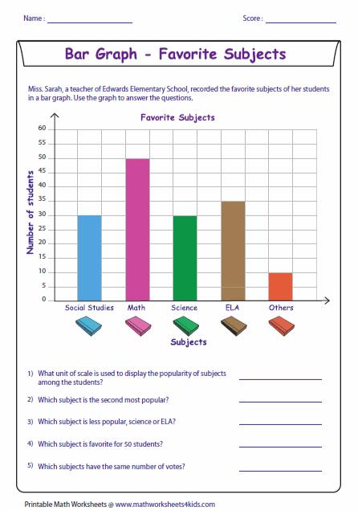
Period :2
Explore: The students will be shown video on different types for representation of data .
https://www.youtube.com/watch?v=s58RgyvbMVI
Group Activity: The students will watch the video & draw the mind map on the paper. Write its one use of day to day life.
Data Presentation
Graphical Method
Pictorial presentation
Tabulation of data
Bar Diagram
Pie Diagram
Histogram
Frequency Polygon
Line Graph

Period : 3

Students will watch the video.
https://www.youtube.com/watch?v=gVr2eYfc4vk
Then they will perform the following activity.
The students will collect the math marks of std 6 students of terminal examination. Teacher will help them to organize the data. They will complete the following blanks:

- Lowest value / observation -------------
- Highest value / observation ------------
- Range of the data :----------------------

Explain: Teacher will help them to analyse & then organize the data.

The students will tabulate the data in grouped frequency distribution table. Grouped frequency distribution table.

Class | Tally | Frequency

Answer the following:

1.Which method will you use to represent the data on graph?
2.How will you tabulate the data grouped / ungrouped ?
2.Name the lower class limit of the class.
3.Write the class width.
4.Write the class with maximum frequency.
5.Find the width of the class
6.Draw the Histogram for your data.

Period : 4

Elaborate : The students will watch this video.

https://www.youtube.com/watch?v=RuERRxn5ecg.

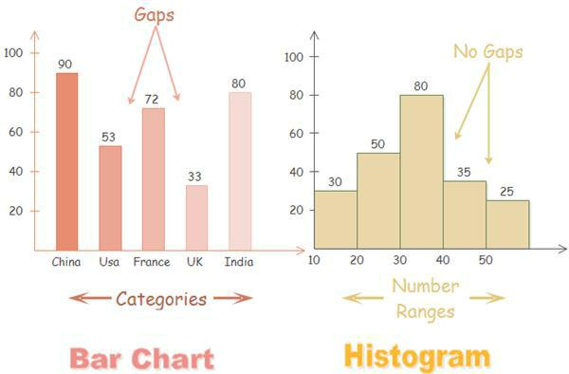
Observe the following Bar graph & Histogram

Teacher will discuss following points with the students.

1 Selection of the scale for both the graphs.
2 Differentiate these graphs by giving the reason .
3 When should we use the histogram?
4 What should be taken on X axis & Y axis?
Teacher will ask them to answer the questions on kahoot.
https://create.kahoot.it/details/3678986b-45c4-4920-be0c-bf2cdcdce95f
https://play.kahoot.it/#/k/21522759-05b2-4d94-86bc-df4c6a03b061

Evaluation:

1.Visit nearby schools like Abhinav English Medium School & Pandit Dindayal Upadhyay Marathi Medium School collect the data of their math marks in Terminal Examination for 20 students (randomly). Represent your data graphically. Write your graphical interpretation.

State your opinion.
This will be evaluated by giving them following rubric.
http://rubistar.4teachers.org/index.php?ts=1543322720

Data Handling

Teacher Name: Mthila Joshi
Student Name: ________________________________________

CATEGORY | 4 | 3 | 2 | 1
Type of Graph Chosen | Graph fits the data well and makes it easy to interpret. | Graph is adequate and does not distort the data, but interpretation of the data is somewhat difficult. | Graph distorts the data somewhat and interpretation of the data is somewhat difficult. | Graph seriously distorts the data making interpretation almost impossible.
Accuracy of Plot | All points are plotted correctly and are easy to see. A ruler is used to neatly connect the points or make the bars, if not using a computerized graphing program. | All points are plotted correctly and are easy to see. | All points are plotted correctly. | Points are not plotted correctly OR extra points were included.
Data Table | Data in the table is well organized, accurate, and easy to read. | Data in the table is organized, accurate, and easy to read. | Data in the table is accurate and easy to read. | Data in the table is not accurate and/or cannot be read.
Labeling of X axis | The X axis has a clear, neat label that describes the units used for the independent variable (e.g, days, months, participants\' names). | The X axis has a clear label that describes the units used for the independent variable. | The X axis has a label. | The X axis is not labeled.
Labeling of Y axis | The Y axis has a clear, neat label that describes the units and the dependent variable (e.g, % of dogfood eaten; degree of satisfaction). | The Y axis has a clear label that describes the units and the dependent variable (e.g, % of dogfood eaten; degree of satisfaction). | The Y axis has a label. | The Y axis is not labeled.
Title | Title is creative and clearly relates to the problem being graphed (includes dependent and independent variable). It is printed at the top of the graph. | Title clearly relates to the problem being graphed (includes dependent and independent variable) and is printed at the top of the graph. | A title is present at the top of the graph. | A title is not present.
Units | All units are described (in a key or with labels) and are appropriately sized for the data set. | Most units are described (in a key or with labels) and are appropriately sized for the data set. | All units are described (in a key or with labels) but are not appropriately sized for the data set. | Units are neither described NOR appropriately sized for the data set.
Neatness and Attractiveness | Exceptionally well designed, neat, and attractive. Colors that go well together are used to make the graph more readable. A ruler and graph paper (or graphing computer program) are used. | Neat and relatively attractive. A ruler and graph paper (or graphing computer program) are used to make the graph more readable. | Lines are neatly drawn but the graph appears quite plain. | Appears messy and \"thrown together\" in a hurry. Lines are visibly crooked.

Home Assignment : 1

1. By using internet prepare the grouped frequency distribution table for terrorist

attack from 2010 to 2017 & number of people killed. Design new method to

represent this information.

Social Awareness:

Write your comment based on following points in such man made disaster.

(1) Role of public (2) Role of media 3) Role of politicians

-----------------------------------------------------------------------------------------------

